The Gardenland/Northgate Neighborhood Association (GNNA) invites you to apply for a scholarship to further your pursuit of higher education. Scholarships will be awarded in the amount of $500.00 and $750.00 to select graduating high school seniors or students continuing their college education. Scholarship applications are available from your career center, your counselor, any member of GNNA, at the Stanford Settlement (450 West El Camino Avenue), www.gnna.info or on Facebook at Gardenland/Northgate Neighborhood Association (GNNA).

ELIGIBILITY REQUIREMENTS:
- Must be currently enrolled as a high school senior, or its equivalent, with a graduation date in the 2018/19 academic year.
- Must have applied to an accredited university or community college. Must also be able to demonstrate proof of registration or admittance.
- Must live within the boundaries of the Gardenland/Northgate Neighborhood Association as defined on Page 6 of this application. Applications will be accepted based on residency rather than school attendance.
- Must be able to provide current school transcript.

OR

5. Must currently be attending an accredited university, community college, or vocational school and can show proof of continuing attendance in the 2019/20 school year. Must still meet eligibility requirements #3 and #4, listed above.

Complete Scholarship application must be RECEIVED by

GNNA Education Committee no later than Monday, May 6, 2019

SELECTION CRITERIA:
- Satisfying eligibility requirements, listed above
- Review of your response to the questions on the attached questionnaire
- 2.0 GPA minimum requirement

OTHER SELECTION CONSIDERATIONS:
- Letter(s) of Recommendation
- Community Involvement
- Civic Engagement
- Extracurricular Activities
- Reserve Officer Training Corps (ROTC)

Josi Juarez Memorial Scholarship

Josi Juarez was a long-time resident of Gardenland/Northgate and member of GNNA for many years. Josi was passionate about our community and realized the importance of community involvement. Along with being the Board Secretary of GNNA, Josi served on the GNNA scholarship committee, helped coordinate the Stanford Settlement May Day Fun Run, and worked on special projects for GNNA.

Josi passed away in 2013 and to honor Josi’s commitment to our community, GNNA is offering a special scholarship of $750.00 to applicants who demonstrate commitment to community service. To apply for this scholarship, follow the same guidelines for the GNNA scholarship however special consideration will be given to applicants who can demonstrate an extra emphasis on community service. Please do not forget to indicate you are interested in being considered for the Josi Juarez Memorial Scholarship, on page 5 of the application.

All applicants who are interested in the Josi Juarez Memorial Scholarship of $750.00 will also be considered for the GNNA Scholarship of $500.00; however applicants can only be awarded one of the two scholarships within an academic year.

SCHOLARSHIP APPLICATION

APPLICANT (Please Print Clearly)

Print Name Today’s Date

Home Address (Number, Street, City, Zip Code)

Home Phone Number Cell Phone Number E-Mail Address

SCHOOL INFORMATION:

Name of School Currently Attending Graduation Date

School Address (Number, Street, City, Zip Code)

____________________________________________________________________________
Name of School Contact Person Contact’s Title Phone Number

How did you hear about the GNNA Scholarship and where did you obtain application?

Would you be interested in serving as a Youth Representative on GNNA’s Board of Directors?
( ) Yes, I’m interested ( ) I would like more info ( ) Not at this time

If you have questions, please contact:
Angie Saunders 916-215-1158 angie1515@comcast.net
Frances Huizar 916-317-5944 fhuizar7@gmail.com
Veronica Herrera 916-413-4024 verherrera@ucdavis.edu
Randee Tavarez RanD49@hotmail.com
Flavio Huizar 916-505-9608 fhuizar@NTW.com

SCHOLARSHIP APPLICATION

Please respond to each of the following statements. PRINT or TYPE your answers on separate sheets and attach them to this package. Please keep your responses to a maximum of 350 words per question.

- Tell us about yourself. Please include what your short and long-term goals are, what your future educational plans are, and anything else you feel is important about you.

- What are some of the good things about your community?

- What are some of the things you would change or add to your community?

- What accomplishment are you most proud of?

- What would you suggest that the GNNA do to involve youths in issues that affect your community?

SCHOLARSHIP APPLICATION

Please initial next to the items that pertain to you:

_______I understand acceptance of a late or incomplete scholarship application is at the discretion of the Education Committee

_______I understand finalists may be asked to participate in a personal interview with the Education Committee

_______I certify I am a graduating high school senior accepted or applying for enrollment in an accredited college or university, for the 2019/2020 academic school year

_______I certify I am a continuing student at an accredited college or university for the 2019/2020 academic school year

_______I authorize Gardenland/Northgate Neighborhood Association to utilize information on my application and any photos for publicity or public relations purposes

_____ I am interested in applying for the Josi Juarez Memorial Scholarship

I certify all the information in this application is true to the best of my knowledge.

________________________________ _______________
Applicant (Print Name) Date

________________________________

Applicant’s Signature

Complete Scholarship application must be RECEIVED by

GNNA Education Committee no later than Mondat May 6, 2019

Include the following items
- Completed scholarship application, pages 3-5
- Valid copy of current academic transcript
- Proof of acceptance or registration at an accredited college or university
- Letter(s) of recommendation – desirable
- Proof of community involvement – desirable

Mail to: GNNA Education Committee (c/o Stanford Settlement)
450 West El Camino Avenue, Sacramento, California 95833-2299

Or, give your application package to a GNNA Board Officer

GNNA BOUNDARIES

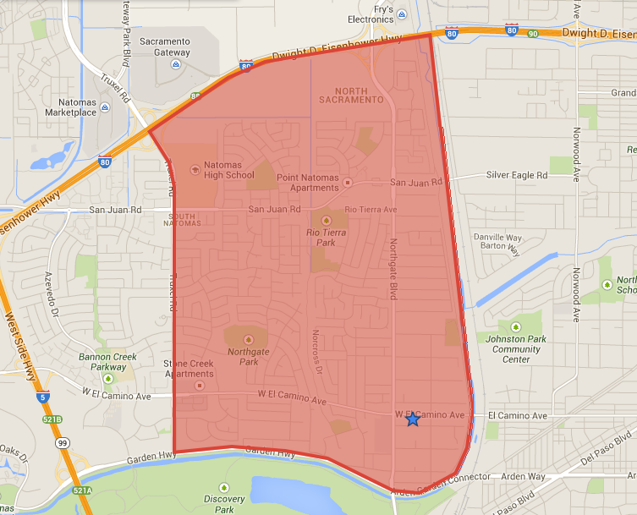

North: CA Interstate 80
East: Steelhead Creek
South: Garden Highway
West: Truxel Road

