GNNA SCHOLARSHIP APPLICATION
2021

The Gardenland/Northgate Neighborhood Association (GNNA) is a community based 501 (c) (3) organization that seeks to improve the quality and safety of our community. Each year, GNNA provides scholarships to graduating seniors that live within the boundaries of Gardenland/Northgate or current college student who is continuing their education and live within the boundaries of GNNA.

Please consider applying to one of our scholarships that provide some financial support as you pursue your education at a community college or an accredited 4 year University. The monetary amount of our scholarships range from $500 to $1250. Applications can be obtained from your career center, your counselor or online through the GNNA Facebook page at Gardenland/Northgate Neighborhood Association or www.GNNA.info

ELIGIBILITY REQUIREMENTS:
- You must be a current high school senior, or its equivalent, with a graduation date in the 2020/21 academic year or a current college student who is continuing their education and meets the rest of the requirements.
- You must have enrolled in an accredited 4 year university or community college and provide proof of registration or acceptance.
- You must live within the boundaries of the Gardenland/Northgate Neighborhood Association as defined on page 5 of this application. Eligibility is based on neighborhood residency and not which school you attended. Living outside the boundaries will disqualify you for consideration.
- You must be in good academic standing and provide your school transcript.

- Two Letters of Recommendations from a teacher, counselor, principal or representative from a community organization.
SELECTION CRITERIA:
- Meeting the above eligibility requirements.
- Essay response to the attached questions.
- 2.5 GPA minimum requirement
- Community Service and/or civic engagement
- Extracurricular Activities

JOSI JUAREZ MEMORIAL SCHOLARSHIP

Josi Juarez was a long-time resident of Gardenland/Northgate and member of GNNA for many years. Josi was passionate about our community and realized the importance of community involvement. Along with being the Board Secretary of GNNA, Josi served on the GNNA scholarship committee, helped coordinate the Stanford Settlement May Day Fun Run, and worked on special projects for GNNA including the annual holiday dinner and park clean-ups.

Josi passed away in 2013 and to honor Josi’s commitment to our community, GNNA is offering a special scholarship of $1000 to applicants who demonstrate commitment to community service. To apply for this scholarship, follow the same guidelines as the GNNA scholarship; however, special consideration will be given to applicants who demonstrate an emphasis on community service. Please do not forget to indicate your interest in being considered for the Josi Juarez Memorial Scholarship.

SCHOLARSHIP APPLICATION

APPLICANT (Please Print Clearly)

Print Name Today’s Date

Home Address (Number, Street, City, Zip Code)

Home Phone Number Cell Phone Number E-Mail Address

SCHOOL INFORMATION:

Name of School Currently Attending Graduation Date

School Address (Number, Street, City, Zip Code)

____________________________________________________________________________
Name of School Contact Person Contact’s Title Phone Number

If you have questions, please contact:
GNNABoard@gmail.com

Scholarship applications must be dropped off or mailed to c/o Stanford Settlement,
450 West El Camino Avenue, Sacramento, CA 95833 no later than Friday, May 14, 2021.

Please respond to each of the following statements. TYPE your answers on separate sheets and attach them to this package. Please keep your responses to a maximum of 350 words per question.

- Describe your short and long-term educational goals and your aspirational goals.

- Describe your community service and/or civil engagement.

- Tell us what you see as the positive attributes of our community.
- The challenges this community faces and one thing you would like to see changed.
Please initial next to the items that pertain to you:

_______I understand I may be asked to participate in a personal interview with the Selection Committee.

_______I authorize Gardenland/Northgate Neighborhood Association to utilize information on my application and any photos for publicity or public relations purposes.

_____ I am interested in applying for the Josi Juarez Memorial Scholarship.

I certify all the information in this application is true to the best of my knowledge.

________________________________ _______________
Applicant (Print Name) Date

________________________________
Applicant’s Signature

Include the following items in your application
A valid copy of your current academic transcript.
Proof of acceptance or registration at an accredited university or community college.
2 Letter(s) of recommendations.
Proof of community involvement and/or civic engagement

GNNA BOUNDARIES

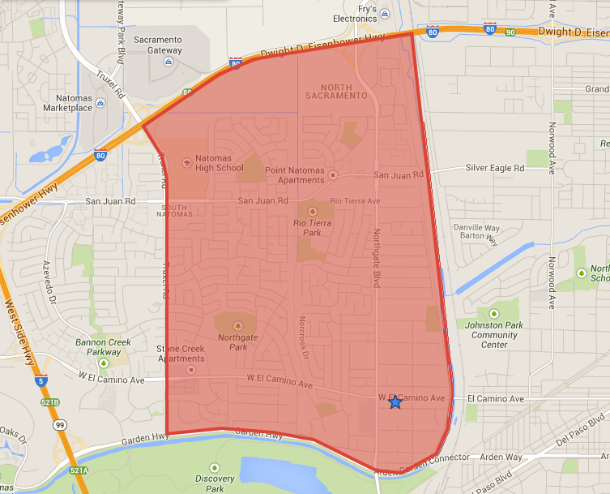

North: CA Interstate 80
East: Steelhead Creek
South: Garden Highway
West: Truxel Road

Scholarship applications must be dropped off or mailed to GNNA c/o Stanford Settlement,
450 West El Camino Avenue, Sacramento, CA 95833 no later than Friday, May 14, 2021.

